Defining a goal and designing the Script

Flowchart

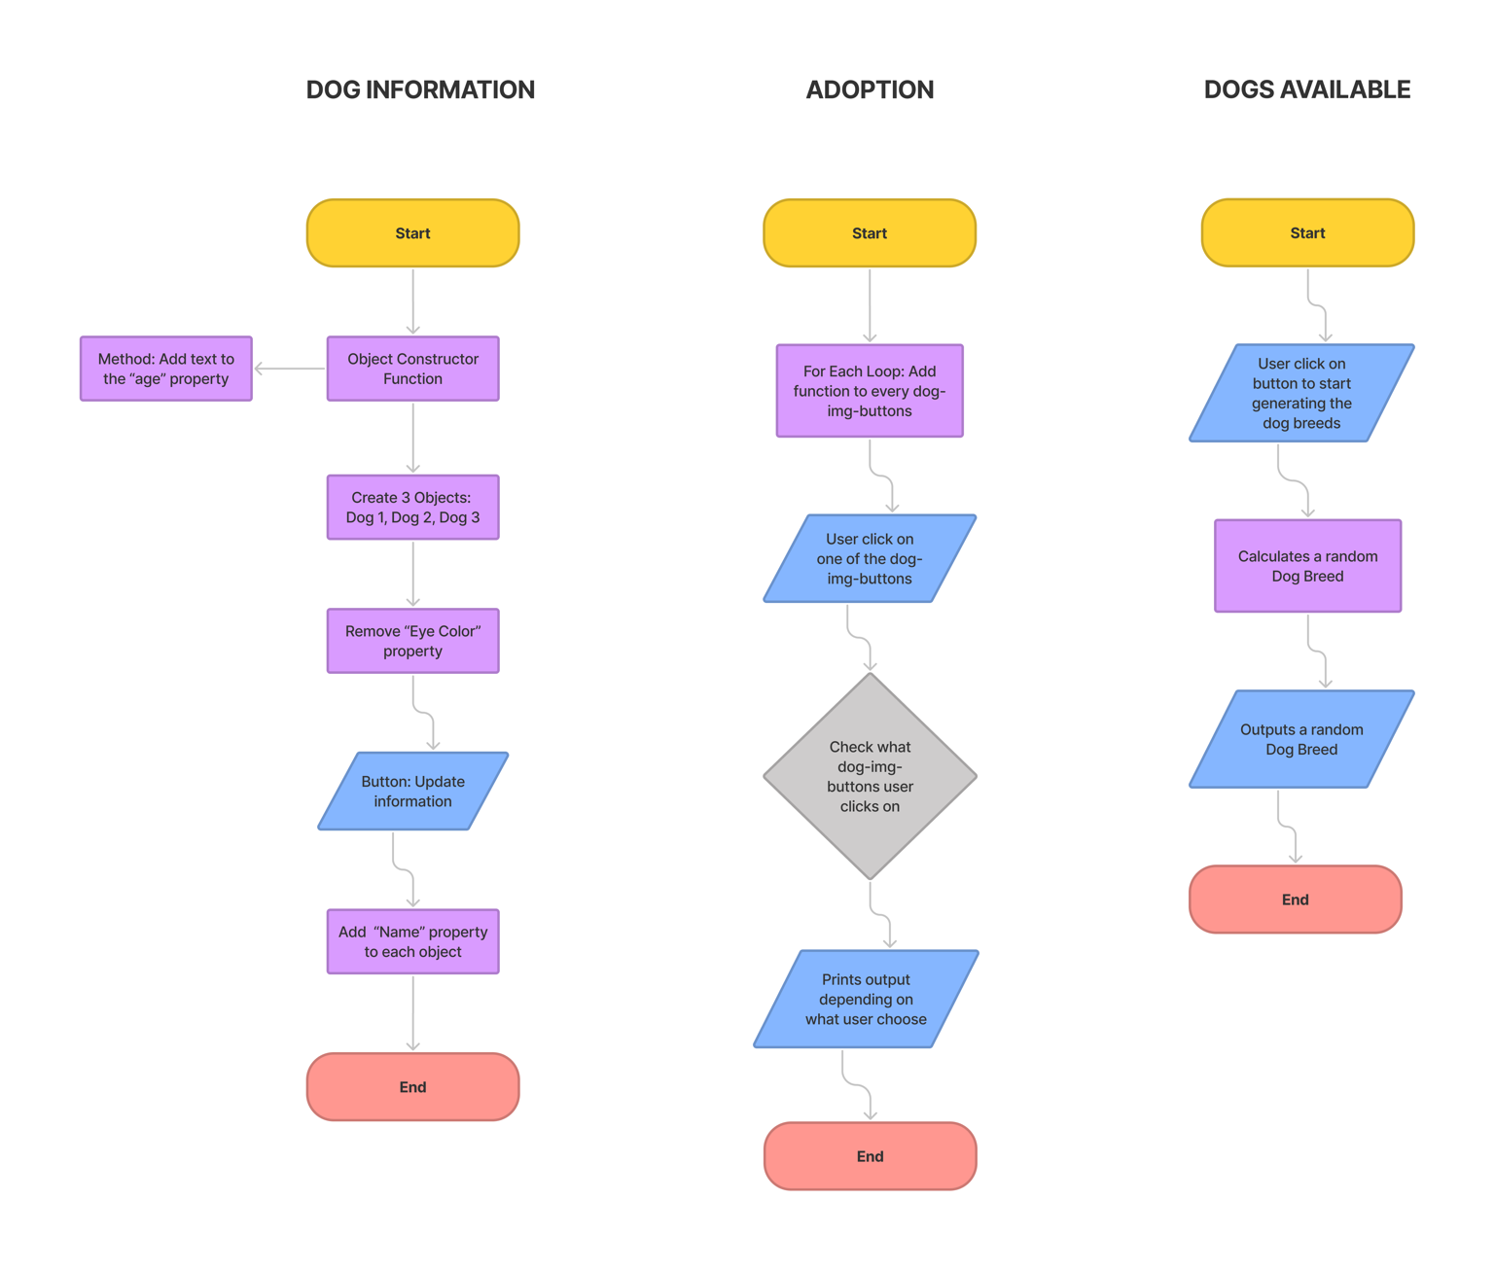

The goal

*p. 14-23 in JavaScript & JQuery by John Duckett*

The goal of this webpage, is to inform the user of a Dog Adoption center. It will highlight the user of three dogs, and show every details needed. There will also be a function that let you pick a dog for adoption. If none of the dogs presented is appealing, you have the option to shuffle through other dog breeds available in the adoption center. There will also be showcased the current date, path and when the website was last modified.

Date, Path & Last Modified

*p. 120-139 in JavaScript & JQuery by John Duckett – (Task 3: 2a, 2b, 2e)*

At the top of the webpage, you can see the current date, the local path, and last modified.

To find todays date, I used the new Date(), getDate(), getMonth(), and getFullYear(), – Date Objects Methods to achieve the result wanted. I used the window.location.pathname – Window Object Method to get the current page path. Used document.lastModified – Document Object Method to get information to when the page was last modified.

Section: Dog Information

*p. 100-119 in JavaScript & JQuery by John Duckett – (Task 3: 1a, 1b, 1c, 1d, 1e, 2b, 2c)*

In this section I started by creating an Object Constructor Function using construction notation, to create the parameters needed for my Objects. It also contains a method, that adds extra text to one of the number parameters. I then created three objects, with the right information. It contains strings, array, number and Boolean. I used the delete property to delete one parameter from each object. To implement the ‘add property’, I made a button that adds information about the dog breed, by clicking it. I displayed the information to the user, by select the correct Query, and use .innerHTML to apply the correct information from the objects.

Section: Adoption

*p. 145-182 in JavaScript & JQuery by John Duckett – (Task 3: 3a, 3b)*

In the Adoption section I have 3 images for the different dogs displayed, that are clickable. To make every image clickable under the same selector, I used .querySelectorAll, and put it in a For Each loop. Inside that loop, I made an Else If statement that checks what image the user clicks on. It will output different messages depending on what image the user chose.

Section: Other Dogs Available

*p. 132-134 in JavaScript & JQuery by John Duckett – (Task 3: 2d)*

If the user is not satisfied with the dogs displayed, it can shuffle through the other dog breeds available. I did this by making an array with several dog breeds, and then added Math.floor and Math.random, and .length, to shuffle a random dog breed from the array to the website.

Documentation

The images used are downloaded from *Unsplash.com*, a copyright-free images website.

The website is backed up in GitHub, and are uploaded in the NTNU Folk site.